**This is a Group Lab – complete it with your group,   
and submit a Group Session Report with this lab.**

Group : 5

Group Members: Kathleen Monks (144 994 209), Sami Dessuky (111 113 205), Ege Kurt (154736193), Umesh Chaudhari (114811201), Matin Pour (151267192)

Section Code: NDD

Date : 2021-11-05

Professor : Marc Gurwitz

**Sale Module**

Jake’s customers are individuals in his community, some of whom have multiple properties.

Jake has developed a list of services and his prices are determined by the number of hours it take for that service. For example, one service would cut lawn and another service would be trim edges.

Jake would like a system that helps him record sales for customers. Ideally, he would like to be able to retrieve sales for customers, so that he can see what happened in the past.

Your task is to create a class diagram and sequence diagrams to support the following user stories and systems use case specifications.

Use Case: Maintain Customer

**User Story**

As the owner of this business, I would like to record my customer’s contact information and a list addresses of properties that they own. Recording property size would help me determine that amount of time that I should schedule for the service

Acceptance Criteria:

1. Must be able to record addresses for a customer
2. Must be able to add a comment to the address to indicate condition and land marks
3. Must be able to query sales by customer.

Use Case Descriptions

|  |  |  |  |
| --- | --- | --- | --- |
| Use Case Name | Create Customer Information | | |
| Triggering Event | New customer requests services. | | |
| Brief Description | Allows the Owner to record a new customer’s information. | | |
| Actors | Owner | | |
| Related Use Cases |  | | |
| Preconditions | Owner has opened the Main Menu. | | |
| Post Conditions | Customer is saved to the database. Sales can be created for the customer | | |
| Flow of activities | Actor | | System |
|  |  | Requests to add a new Customer | Prompts for Customer name, address, telephone and email address |
|  |  | Enters customer name, billing address, telephone number and email address | Verifies that name, address, telephone number and email address have been entered.  Creates a unique customer identifier  Displays the customer’s identifier, name, billing address, telephone number and email address  Prompts to add property addresses |
|  | loop | Chooses to add new address | Prompts for address, property size and comment |
|  |  | Enters address, property size and comment | Address and property size must be entered.  Data is valid  Creates a unique address identifier  Displays the address information including address, size and comment. |
|  | End loop | Request to save | Saves the customer and addresses |
| Exception Conditions | * Owner chooses to cancel adding the customer | | |

**User Story**

As the owner of this business, I would like to record my sales so that I can quickly see how much money I’ve made.

Acceptance Criteria:

1. Must be able to record multiple services for multiple addresses belonging to a customer in one sale
2. Must be able to query sales by customer.

Use Case Descriptions

|  |  |  |  |
| --- | --- | --- | --- |
| Use Case Name | Create Sales | | |
| Triggering Event | Customer has requested service and the service is complete | | |
| Brief Description | Allows the Owner to record a new sales | | |
| Actors | Owner | | |
| Related Use Cases |  | | |
| Preconditions | Owner has opened the Main Menu. | | |
| Post Conditions | Sales is created and can now be queried | | |
| Flow of activities | Actor | | System |
|  | 1. | Requests to add a new sale | Displays a list of customers and prompts for selection |
|  | 2. | Selects a customer | Prompts for service date |
|  | 3 | Enters service date | Verifies that service date has been entered and generates a unique sale number. Prompts to select addresses |
|  | loop | Chooses to add an address | Displays a list of addresses and prompts for selection |
|  | 4. | Selects the address | Prompts to select services |
|  | Loop2 | Chooses to add services | Displays a list of services including service name, service type and price/hour prompting for selection |
|  | 5. | Selects services that apply | Adds services to the sale. |
|  | 6. | Updates hours and price | Calculates the detail amount (hours * price). Calculates taxes and updates sale total. Displays the sale total, total taxes, sale service details, prompting for changes to hours and price  Prompts for another address  Prompts to save |
|  | End2 | Until all services for an address have been selected |  |
|  | End | Until addresses have been selected. | Displays the sale total, total taxes, sale service details and prompts to save |
|  | 5. | Chooses to save | Saves the sale.  Return to the main menu |
| Exception Conditions | * Owner chooses to cancel adding the sale | | |

|  |  |  |  |
| --- | --- | --- | --- |
| Use Case Name | Query Sales by Customer | | |
| Triggering Event | Owner requires a list of sale details by customer | | |
| Brief Description | Allows the Owner to retrieve sale details for a specific customer for a specified date range | | |
| petActors | Owner | | |
| Related Use Cases |  | | |
| Preconditions | Owner has opened the Main Menu. | | |
| Post Conditions | sales are retrieved, totaled and displayed | | |
| Flow of activities | Actor | | System |
|  |  | Requests to query sales (by customer, by date) transactions | Displays a calendar |
|  |  | Selects date range | Verifies that dates are selected. Displays a list of customers and prompts for selection |
|  |  | Selects a customer | Retrieves sale detail in the specified date range for the specified customer.  Calculate and displays totals  Prompts to exit |
|  |  | Request to exit | returns to the main menu |
| Exception Conditions | Owner requests to cancel query | | |

Your tasks:

1. Create a class diagram to support the above case study and Systems Use Case Specifications
2. Create an object level sequence diagram, detailing the Create Customer systems use case specification
3. Create an object level sequence diagram, detailing the Create Sales use case specification
4. Create an object level sequence diagram, detailing the Query Sales (by customers) system use case specification.

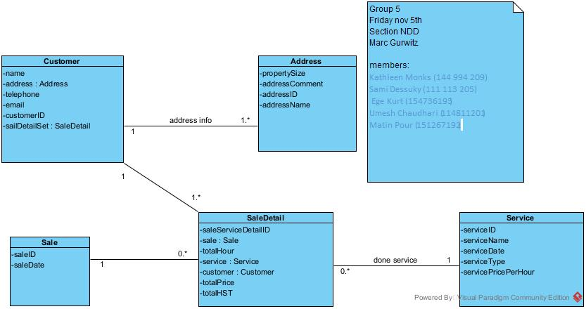

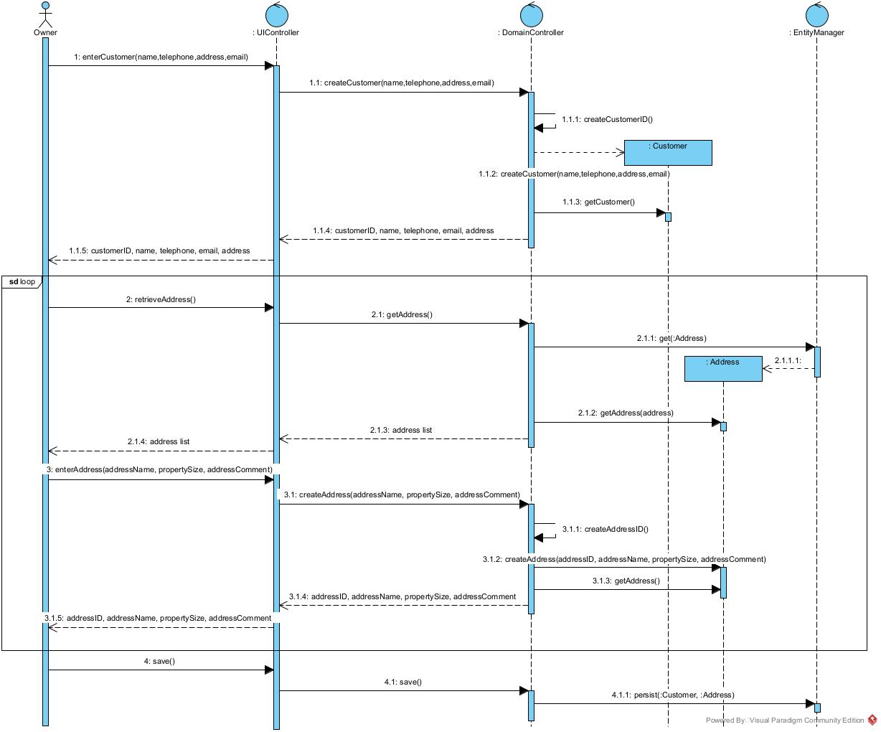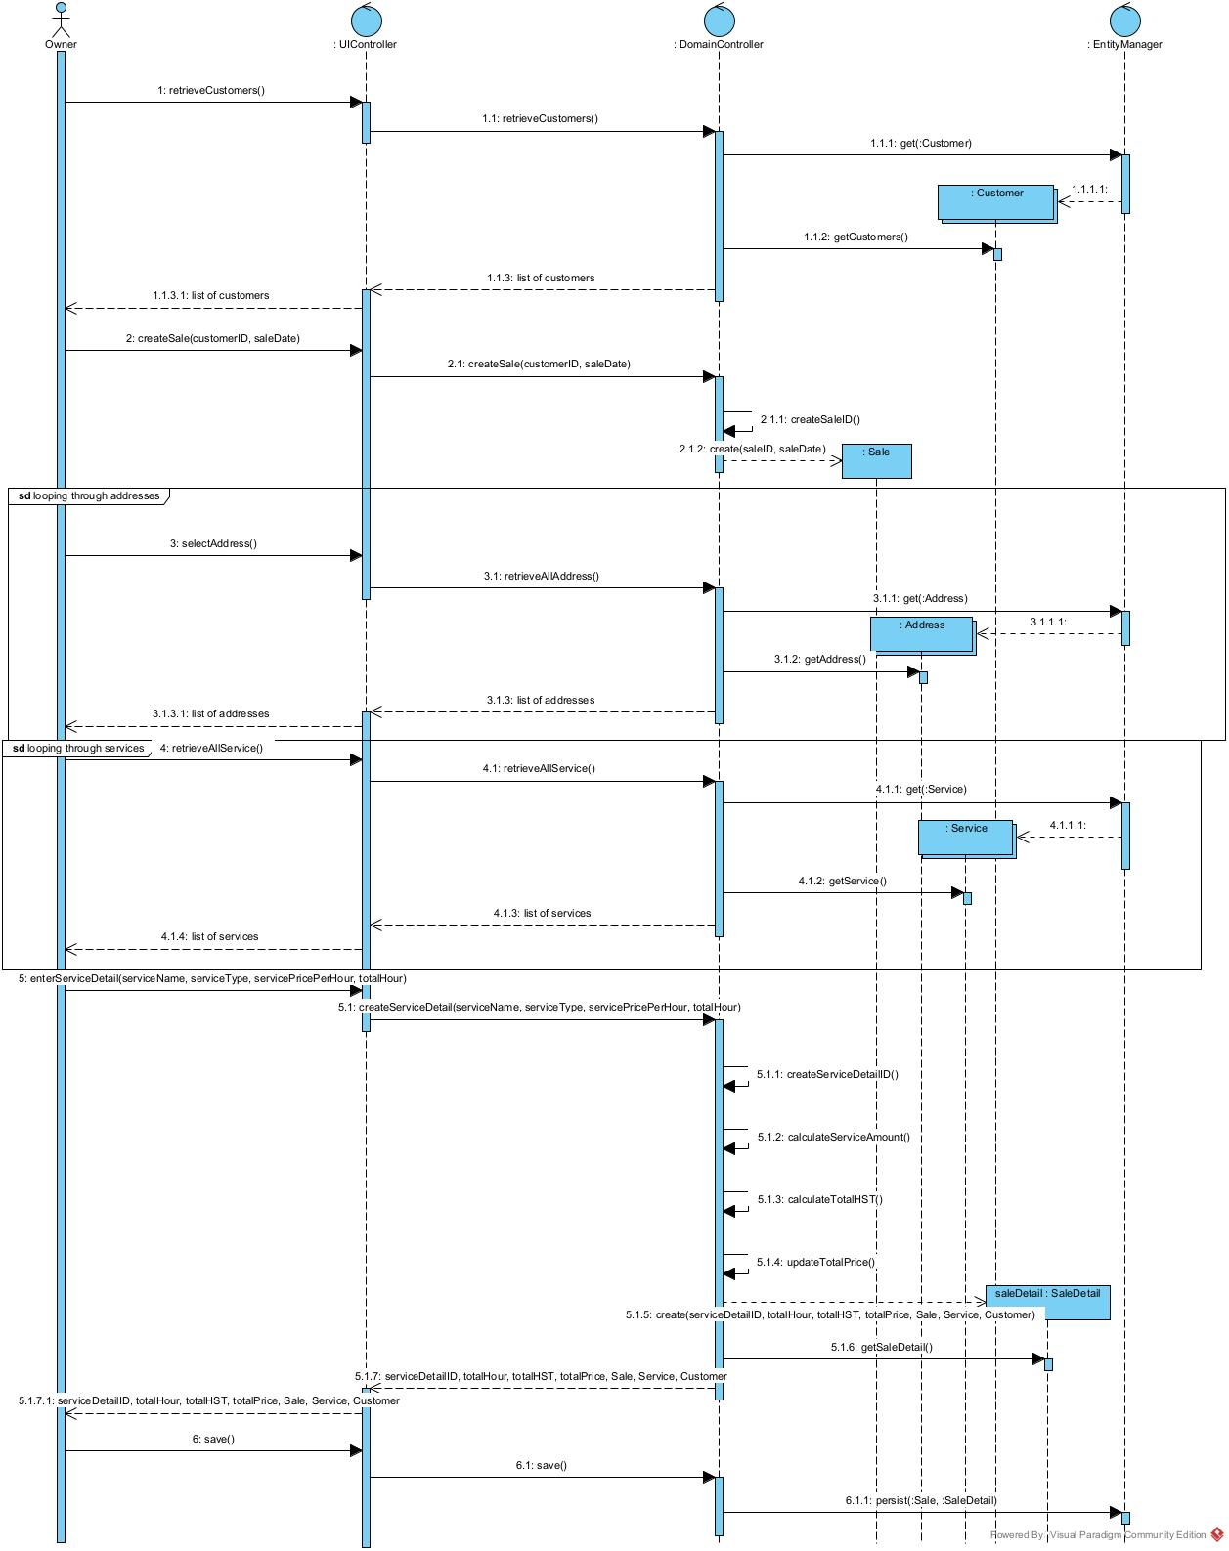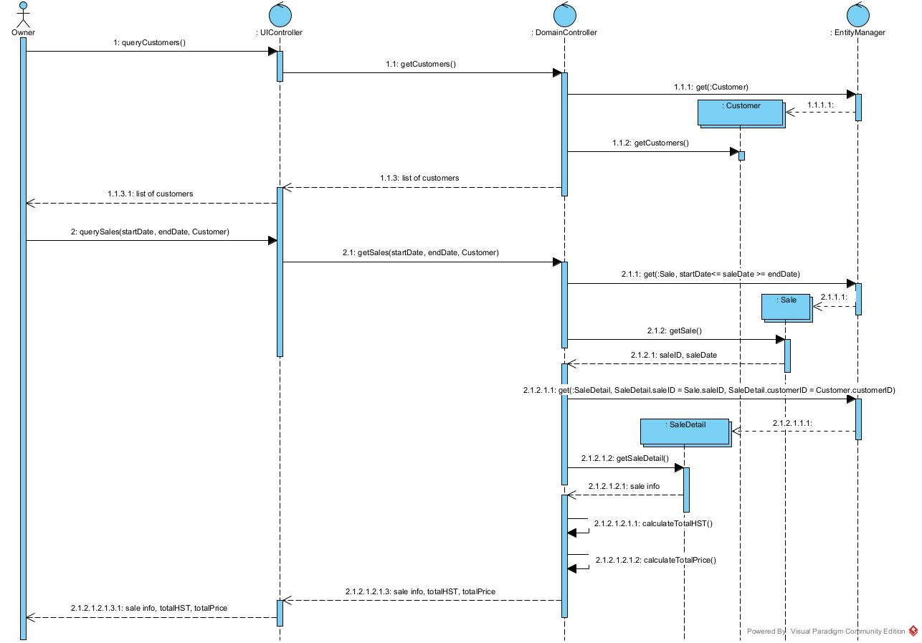

Lab Marks:

|  |  |
| --- | --- |
| Submit UML model on time | 1 |
| Discussion participation | 2 |
| Total | 3 |